**Blockchain Technologies**

**Journal**

Submitted By

**Tagadghar Shailesh Ashok**

Roll No: 31031523034

MSc CS – Part Ⅱ

**Department Of Computer Science**

**Somaiya Vidyavihar University**

**SK Somaiya College**

Index:

|  |  |
| --- | --- |
| Practical No | Title |
| 1. | 1. Creating a simple blockchain to calculate sum of two number. 2. Creating a simple blockchain to calculate factorial of a number. |
| 2. | Creating a simple blockchain to check whether a number is happy or not. |
| 3. | Creating a simple blockchain to check and validate a Kaprekar number. |
| 4. | Create a simple blockchain to store only automorphic number also secure your automorphic number by DES Algorithm and validate the block before adding it to the blockchain. |
| 5. | Create a simple blockchain to record deposit and withdrawal transactions. |
| 6. | 1. Create a smart contract for addition of two numbers. 2. Write a simple auction contract where a user can bid on an item and the highest bidder wins. |
| 7. | 1. Write a smart contract to display factorial of a number. 2. Write a smart contract to display nth term of Fibonacci series. 3. Write a smart contract to check if the number is prime or not. 4. Write a smart contract to deposit and withdraw money. |
| 8. | 1. Create a smart contract to calculate mean of n numbers. 2. Create a smart contract to calculate median of n numbers. 3. Create a smart contract to create a student portal and register a new student having the details Name, IdNo, Address, 3 subject marks, percentage and grade. |
| 9. | Write a smart contract to create a voting application. |
| 10. | 1. Write a smart contract for Single Level Inheritance. 2. Write a smart contract for Multi-Level Inheritance. 3. Write a smart contract for Multiple Inheritance. 4. Write a smart contract for Hierarchical Inheritance. |
| 11. | Creating a simple DApp for performing basic mathematical operations on two numbers. |
| 12. | Create a DApp to calculate factorial of a number.  Create a DApp to implement transactions between two accounts.  Create a DApp to implement elections. |
| 13. | Storing and Retrieving files using IPFS. |

Practical 1A: Creating a simple blockchain to calculate sum of two number.

Code:

1. blockchain.js

|  |
| --- |
| const c = require('crypto')    class Block {  constructor(i, t, n1, n2, ph = '') { this.i = i; this.t = t; this.n1 = n1; this.n2 = n2; this.sum = n1 + n2; this.ph = ph;  this.h = this.calHash();  }  calHash() {  return c.createHash('sha256').update(this.i + this.t + this.sum + this.ph).digest('hex');  }  }  class Blockchain { constructor() {  this.chain = [this.createGBlock()];  }  createGBlock() {  return new Block(0, '01/08/2024', 0, 0, '0'); }  getCBlock() {  return this.chain[this.chain.length - 1];  }  addBlock(nb) {  nb.ph = this.getCBlock().h; |

|  |
| --- |
| nb.h = nb.calHash(); this.chain.push(nb);  }  }  module.exports.Block = Block; module.exports.Blockchain = Blockchain; |

1. test.js

const { b, bc, Blockchain, Block } = require('./blockchain')

let mb = new Blockchain();

console.log("Developed by SHAILESH - 31031523034"); console.log("First Transaction");

mb.addBlock(new Block(1, '01/08/2024', 23, 5)); console.log(JSON.stringify(mb, null, 3));

Output:

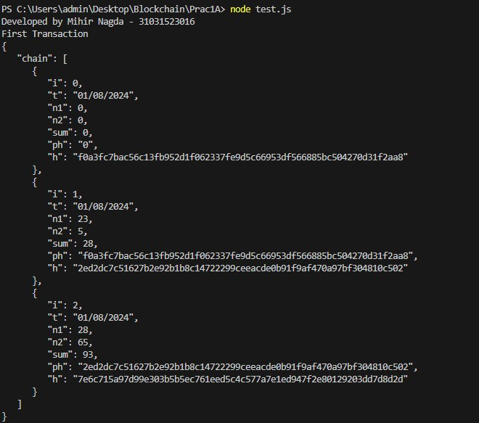

Practical 1B: Creating a simple blockchain to calculate factorial of a number.

Code:

1. blockchain.js

|  |
| --- |
| const c = require('crypto')    class Block {  constructor(i, t, n, ph = '') { this.i = i; this.t = t; this.n = n;  this.fact = this.factorial(n); this.ph = ph;  this.h = this.calHash();  }  factorial(n) { let ans = 1;    if (n === 0) return 1;  for (let i = 2; i <= n; i++) ans = ans * i; return ans;  }  calHash() {  return c.createHash('sha256').update(this.i + this.t + this.sum + this.ph).digest('hex');  }  }  class Blockchain { constructor() {  this.chain = [this.createGBlock()];  }  createGBlock() { |
| return new Block(0, '01/08/2024', 0, 0, '0'); }  getCBlock() {  return this.chain[this.chain.length - 1];  }  addBlock(nb) {  nb.ph = this.getCBlock().h; nb.h = nb.calHash(); this.chain.push(nb);  }  }  module.exports.Block = Block; module.exports.Blockchain = Blockchain; |

1. test.js

|  |
| --- |
| const { b, bc, Blockchain, Block } = require('./blockchain')    let mb = new Blockchain();  console.log("Developed by SHAILESH - 31031523034")    mb.addBlock(new Block(1, '01/08/2024', 5)) mb.addBlock(new Block(2, '01/08/2024', 12)) console.log(JSON.stringify(mb, null, 3)); |

Output:

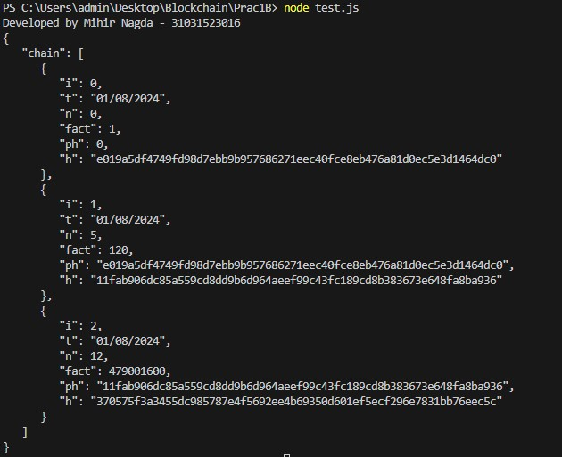

Practical 2: Creating a simple blockchain to check whether a number is happy or not.

Code:

1. blockchain.js

|  |
| --- |
| const c = require('crypto')    class Block {  constructor(i, t, n, ph = '') { this.i = i; this.t = t; this.n = n;  this.happy = this.isHappy(); this.ph = ph;  this.h = this.calHash();  }  isHappy() {  let temp = this.n; while (temp > 9) { let sum = 0; while (temp > 0) {  let remainder = temp % 10; temp = Math.floor(temp / 10); let sqr = remainder * remainder; sum += sqr;  } temp = sum;  }    if (temp == 0) { return "0";  // console.log("0")  } |

|  |
| --- |
| else if (temp == 1) { return "Happy number";  // console.log("HappyNumber")  }    else {  return "Not a Happy Number"  // console.log("Not a HappyNumber")  }  }  calHash() {  return c.createHash('sha256').update(this.i + this.t + this.happy + this.ph).digest('hex');  }  }  class Blockchain { constructor() {  this.chain = [this.createGBlock()];  }  createGBlock() {  return new Block(0, new Date(), 0, '0');  }  getCBlock() {  return this.chain[this.chain.length - 1];  }  addBlock(nb) {  nb.ph = this.getCBlock().h; nb.h = nb.calHash(); this.chain.push(nb);  } |
| }  module.exports.Block = Block; module.exports.Blockchain = Blockchain; |

1. test.js

const { Block, Blockchain } = require('./blockchain');

let mb = new Blockchain();

console.log("Developed by SHAILESH - 31031523034")

mb.addBlock(new Block(1, new Date(), 10)); mb.addBlock(new Block(2, new Date(), 15)); console.log(JSON.stringify(mb, null, 3));

Output:

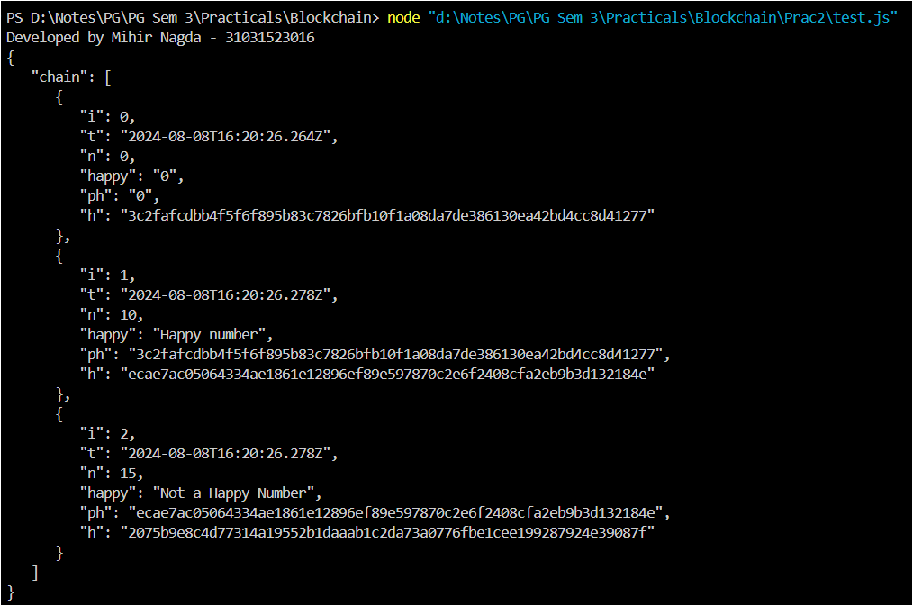

Practical 3: Creating a simple blockchain to check and validate a Kaprekar number.

Code:

1. blockchain.js

|  |
| --- |
| const c = require('crypto')    class Block {  constructor(i, t, n, ph = '') { this.i = i; this.t = t; this.n = n;  this.kaprekar = this.kap(); this.ph = ph;  this.h = this.calHash();  }  /* kap() {  let n1 = this.n; let sq = n1 * n1; let s = 0; let c = 0;    while (sq != 0) { // let r = sq % 10; c = c + 1;  sq = Math.floor(sq / 10);  }    for (let i = 1; i < c; i++) { let sq1 = n1 * n1; s = 0;  while (sq1 != 0) {  let r = sq1 % Math.pow(10, i); |

|  |
| --- |
| s = s + r;  sq1 = Math.floor(sq1 / Math.pow(10, i)); }    if (this.n == s) {  // return "Kaprekar Number"; this.kaprekar = "Kaprekar Number"; break;  } else {  // return "Not Kaprekar Number"; this.kaprekar = "Not a Kaprekar Number";  }  }    return this.kaprekar;  }  */    kap() {  let n = this.n; if (n < 1) { return false;  }    let square = n * n;  let squareStr = square.toString(); let len = squareStr.length;    let left = parseInt(squareStr.substring(0, Math.floor(len / 2))) || 0; let right = parseInt(squareStr.substring(Math.floor(len / 2))) || 0;    if (left + right === n) { return "Kaprekar Number";  } |

|  |
| --- |
| else {  return "Not a Kaprekar Number";  }  }  calHash() {  return c.createHash('sha256').update(this.i + this.t + this.kaprekar + this.ph).digest('hex');  }  }  class Blockchain { constructor() {  this.chain = [this.createGBlock()];  }  createGBlock() {  return new Block(0, new Date(), 0, '0');  }  getCBlock() {  return this.chain[this.chain.length - 1];  }  addBlock(nb) {  nb.ph = this.getCBlock().h; nb.h = nb.calHash(); this.chain.push(nb);  }  validate() {  for (let i = 1; i < this.chain.length; i++) { let cb = this.chain[i] let pb = this.chain[i - 1] |
| if (cb.h != cb.calHash()) { return false;  }    if (pb.h != cb.ph) { return false;  }  }    return true;  }  }  module.exports.Block = Block; module.exports.Blockchain = Blockchain; |

1. test.js

const { Block, Blockchain } = require('./blockchain'); let mb = new Blockchain();

console.log("Developed by SHAILESH - 31031523034")

mb.addBlock(new Block(1, new Date(), 45)); mb.addBlock(new Block(2, new Date(), 19)); mb.addBlock(new Block(3, new Date(), 297)); console.log("Chain Valid:", mb.validate()); console.log(JSON.stringify(mb, null, 3));

Output:

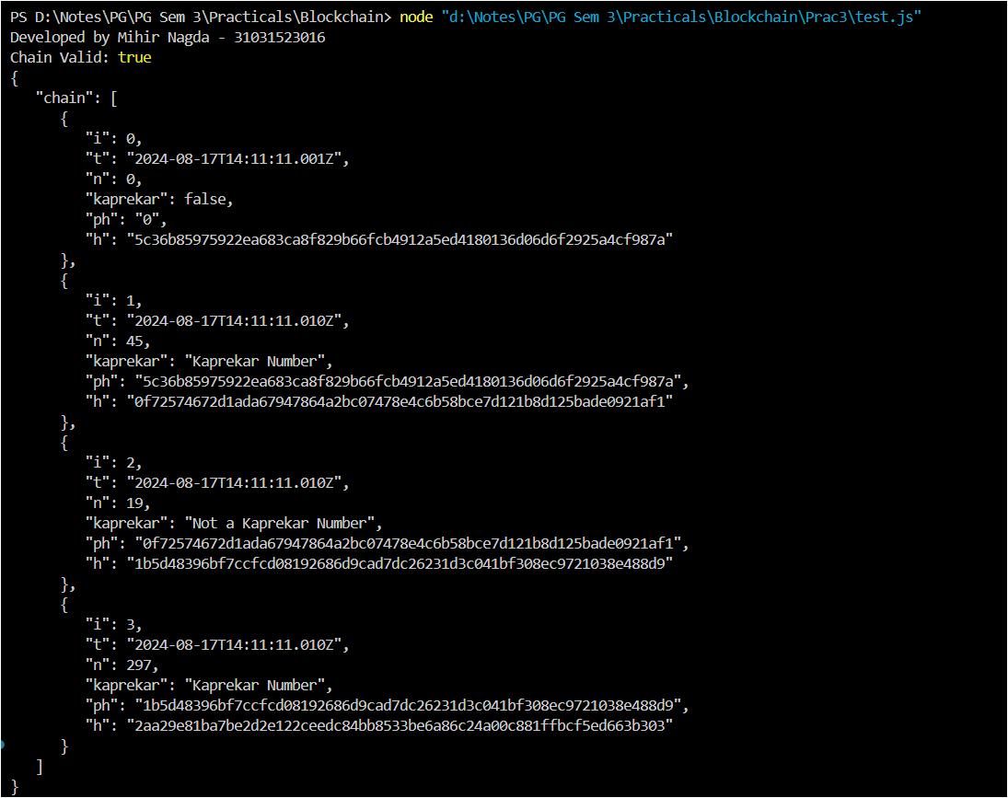

Practical 4: Create a simple blockchain to store only automorphic number also secure your automorphic number by DES Algorithm and validate the block before adding it to the blockchain.

Code:

1. blockchain.js

|  |
| --- |
| const c = require('crypto')    class Block {  constructor(i, t, n, ph = '') { this.i = i; this.t = t; this.n = this.enc(n);  this.automorphic = this.morph(); this.ph = ph;  this.h = this.calHash();    }  morph() {  let n1 = this.dec(this.n); let squared = n1 * n1;    let numStr = n1.toString(); let squaredStr = squared.toString();    let result = squaredStr.endsWith(numStr);    if (result == true) { return "Automorphic Number"  } else {  return "Not an Automorphic Number"  }  } |

|  |
| --- |
| enc(text) {  const key = c.scryptSync('password', 'salt', 32); const iv = c.randomBytes(16);  const cipher = c.createCipheriv('aes-256-cbc', key, iv); const encrypted = cipher.update(text.toString(), 'utf8', 'hex') + cipher.final('hex');  return iv.toString('hex') + ':' + encrypted;  }  dec(encryptedText) {  const key = c.scryptSync('password', 'salt', 32); const [ivHex, encrypted] = encryptedText.split(':'); const iv = Buffer.from(ivHex, 'hex');  const decipher = c.createDecipheriv('aes-256-cbc', key, iv); const decrypted = decipher.update(encrypted, 'hex', 'utf8') + decipher.final('utf8');  return parseInt(decrypted, 10);  }  calHash() {  return c.createHash('sha256').update(this.i + this.t + this.automorphic + this.ph).digest('hex');  }  }  class Blockchain { constructor() {  this.chain = [this.createGBlock()];  }  createGBlock() {  return new Block(0, new Date(), 0, '0');  }  getCBlock() { |
| return this.chain[this.chain.length - 1];  }  addBlock(nb) {  if (nb.morph() == "Automorphic Number") { nb.ph = this.getCBlock().h; nb.h = nb.calHash(); this.chain.push(nb);  }    }  validate() {  for (let i = 1; i < this.chain.length; i++) { let cb = this.chain[i] let pb = this.chain[i - 1]    if (cb.h != cb.calHash()) { return false;  }    if (pb.h != cb.ph) { return false;  }  }    return true;  }  }  module.exports.Block = Block; module.exports.Blockchain = Blockchain; |

1. test.js

const { Blockchain, Block } = require('./blockchain')

let mb = new Blockchain();

console.log("Developed by SHAILESH - 31031523034")

mb.addBlock(new Block(1, new Date(), 5)) mb.addBlock(new Block(2, new Date(), 7)) mb.addBlock(new Block(3, new Date(), 6))

console.log(mb.validate()); console.log(JSON.stringify(mb, null, 3))

Output:

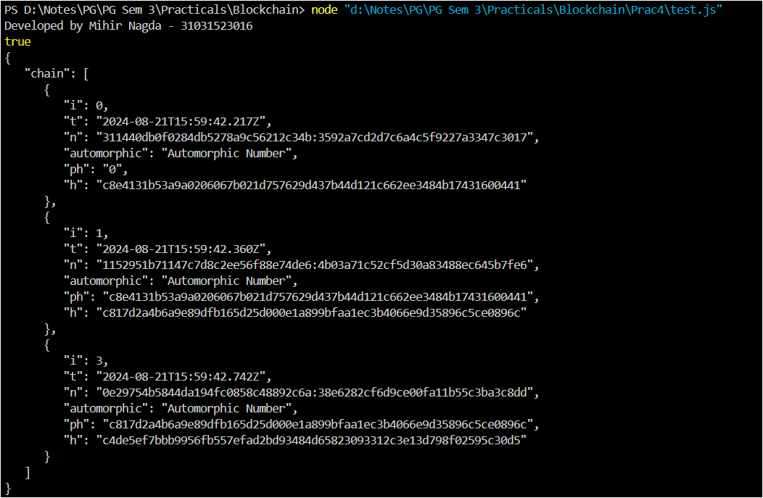

Practical 5: Create a simple blockchain to record deposit and withdrawal transactions.

Code:

blockchain.js

|  |
| --- |
| const c = require('crypto')    class Block {  constructor(i, t, op, m, b = 0, ph = '') { this.i = i; this.t = t; this.op = op; this.m = m; this.b = m; this.ph = ph;  this.h = this.calHash();    }  calHash() {  return c.createHash('sha256').update(this.i + this.t + this.op + this.b + this.ph).digest('hex');  }  }  class Blockchain { constructor() {  this.chain = [this.createGBlock()];  }  createGBlock() {  return new Block(0, new Date(), 'D', 1000, 0, '0'); }  getCBlock() {  return this.chain[this.chain.length - 1];  } |

|  |
| --- |
| addBlock(nb) {  nb.ph = this.getCBlock().h;    if (nb.op == "D") {  nb.b = this.getCBlock().b + nb.m;  }  else if (nb.op == "W") {  if (this.getCBlock().b > nb.m) { nb.b = this.getCBlock().b - nb.m;  } else {  nb.b = this.getCBlock().b;  } } else {  console.log("Not a Valid Operation.")  }    nb.h = nb.calHash(); this.chain.push(nb);  }  validate() {  for (let i = 1; i < this.chain.length; i++) { let cb = this.chain[i] let pb = this.chain[i - 1]    if (cb.h != cb.calHash()) { return false;  }    if (pb.h != cb.ph) { return false;  }  }    return true;  } |
| }  module.exports.Block = Block; module.exports.Blockchain = Blockchain; |

test.js:

|  |
| --- |
| const { Blockchain, Block } = require('./blockchain')  let mb;  console.log("Developed by Mihir Nagda - 31031523016")    const readline = require('readline').createInterface({ input: process.stdin, output: process.stdout  });  async function main() { mb = new Blockchain(); let i = 1; while (true) {  const DW = await new Promise(resolve => {  readline.question('Type D - Deposit, W - Withdraw or Any Other  Charcter - Exit: ', resolve);  });    if (DW.toUpperCase() !== 'D' && DW.toUpperCase() !== 'W') { console.log('Exiting...'); break;  }    const m = await new Promise(resolve => { readline.question('Enter Amount: ', resolve); });    mb.addBlock(new Block(i, new Date(), DW, parseInt(m))); console.log(JSON.stringify(mb, null, 3)); i++; |
| }  readline.close();  } main(); |

Output:

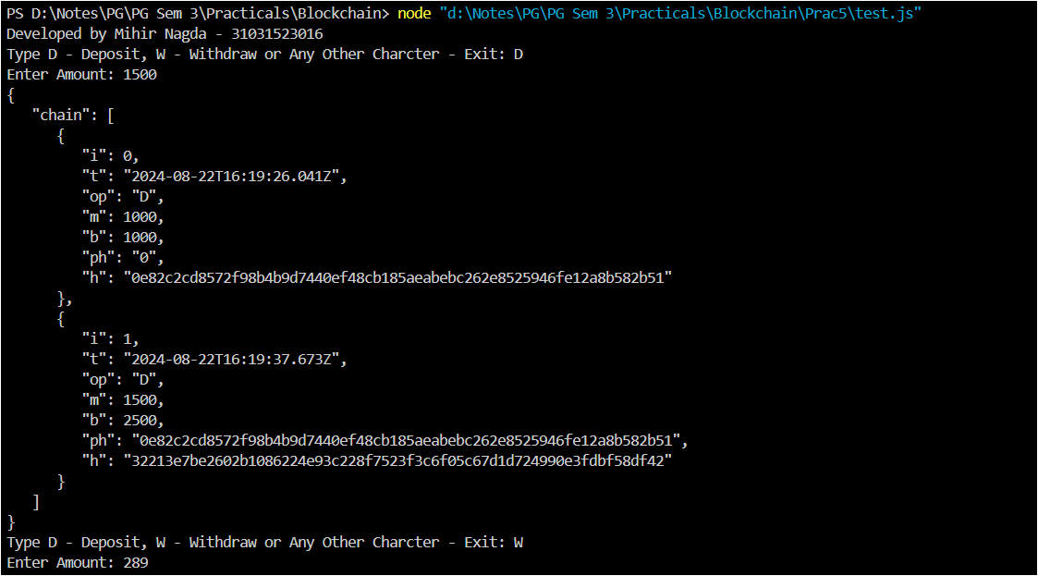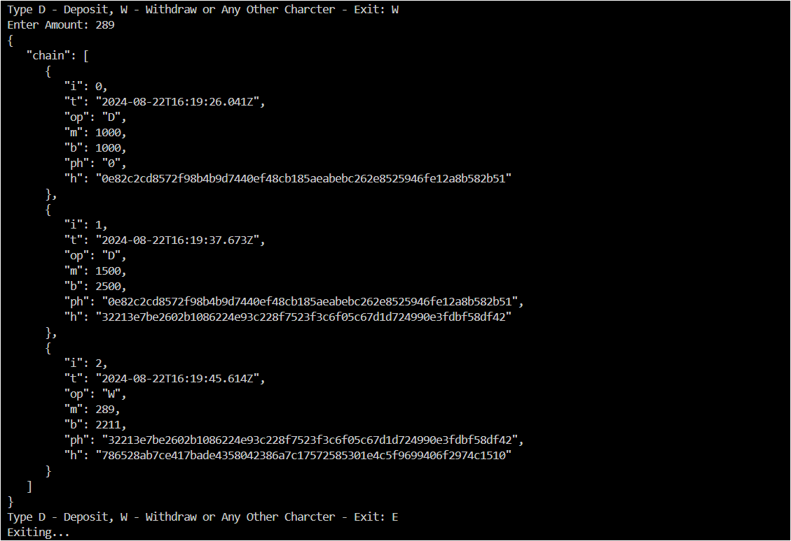

Practical 6A: Create a smart contract for addition of two numbers.

Code:

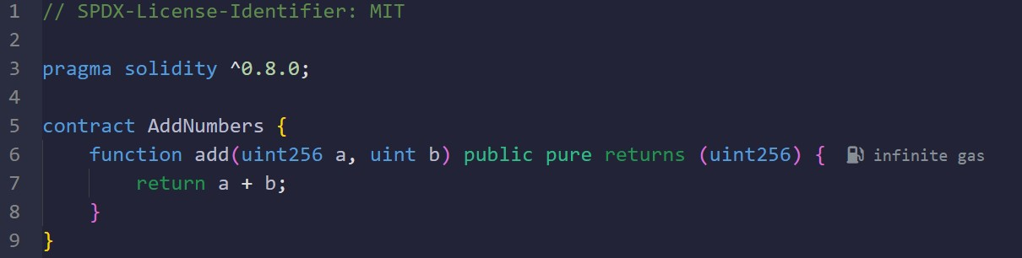

Output:

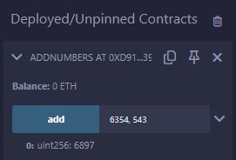

Practical 6B: Write a simple auction contract where a user can bid on an item and the highest bidder wins.

Code:

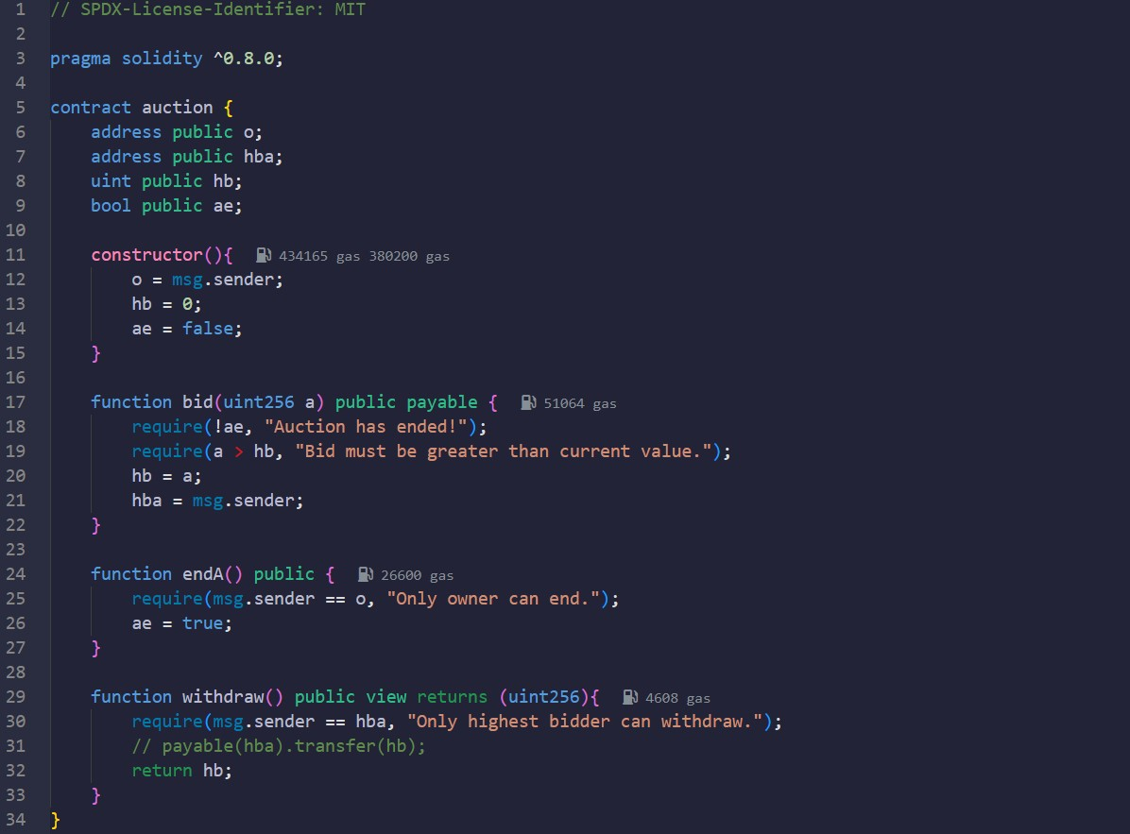

Output:

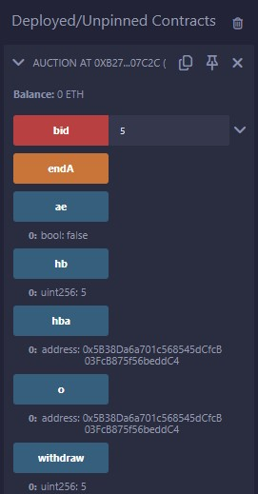

Practical 7A: Write a smart contract to display factorial of a number.

Code:

|  |
| --- |
| //SPDX-License-Identifier: MIT    pragma solidity ^0.8.0;    contract factorial{  function fact(uint256 a) public pure returns(uint256){ uint256 ans = 1;  for (uint256 i = 2; i <= a; i++){ ans = ans * i;  } return ans;  }  } |

Output:

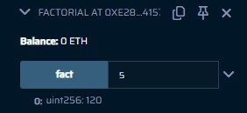

Practical 7B: Write a smart contract to display nth term of Fibonacci series.

Code:

|  |
| --- |
| //SPDX-License-Identifier: MIT    pragma solidity ^0.8.0;    contract fibo{  function fib(uint256 a) public pure returns(uint256){ uint256 n1 = 0; uint256 n2 = 1; uint256 n3;    for (uint256 i = 3; i <= a; i++){ n3 = n1 + n2; n1 = n2; n2 = n3;  } return n3;  }  } |

Output:

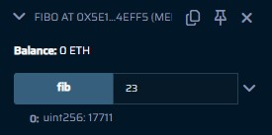

Practical 7C: Write a smart contract to check if the number is prime or not.

Code:

|  |
| --- |
| //SPDX-License-Identifier: MIT    pragma solidity ^0.8.0;    contract prime{  function primee(uint256 a) public pure returns(bool){ for (uint256 i = 2; i < a; i++){ if(a % i == 0){ return false;  } }  return true;  }  } |

Output:

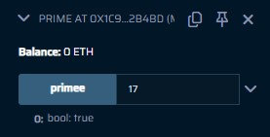

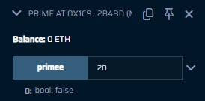

Practical 7D: Write a smart contract to deposit and withdraw money.

Code:

|  |
| --- |
| //SPDX-License-Identifier: MIT    pragma solidity ^0.8.0;    contract Bank{ address public s; uint256 public bal;    constructor(){ s = msg.sender; bal = 0;  }  function deposit(uint256 a) public { bal += a; s = msg.sender;  }  function withdraw(uint256 a) public{ if(bal >= a){ bal -= a;  }  s = msg.sender;  }  function displayOwn() public view returns(address){ return s;  }  } |

Output:

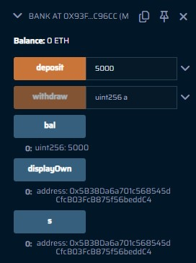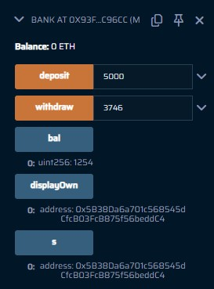

Practical 8A: Create a smart contract to calculate mean of n numbers.

Code:

|  |
| --- |
| //SPDX-License-Identifier: MIT    pragma solidity ^0.8.0;    contract meanNo {  function mean(uint256[] memory arr) public pure returns(uint256){ uint res = 0;    for(uint i = 0; i < arr.length; i++){ res = res + arr[i];  }    return res = res / arr.length;  }  } |

Output:

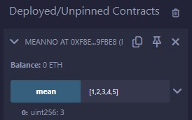

Practical 8B: Create a smart contract to calculate median of n numbers.

Code:

|  |
| --- |
| // SPDX-License-Identifier: MIT    pragma solidity ^0.8.0;    contract medianNo {  function median(uint256[] memory arr) public pure returns (uint256) { uint256 n = arr.length;  for (uint256 i = 0; i < n - 1; i++) { for (uint256 j = 0; j < n - i - 1; j++) { if (arr[j] > arr[j + 1]) {  (arr[j], arr[j + 1]) = (arr[j + 1], arr[j]);  }  }  }    uint256 med; if (n % 2 == 0) {  med = (arr[n / 2 - 1] + arr[n / 2]) / 2;  } else {  med = arr[n / 2];  }    return med;  }  } |

Output:

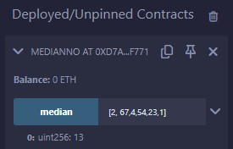

Practical 8C: Create a smart contract to create a student portal and register a new student having the details Name, IdNo, Address, 3 subject marks, percentage and grade.

Code:

|  |
| --- |
| // SPDX-License-Identifier: MIT    pragma solidity ^0.8.0;    contract studentC{ struct std{ uint sid; string name; address addr; uint BCT; uint ML; uint BDA; uint percent; string grade;  }  mapping(uint256 => std) public student;  function register(uint i, string memory n, uint b, uint m, uint a) public { student[i].name = n; student[i].addr = msg.sender; student[i].sid = i; student[i].BCT = b; student[i].ML = m; student[i].BDA = a;    uint p = (b + m + a) / 3; student[i].percent = p;    if(p >= 80){  student[i].grade = "O";  }  else if(p >= 60 && p < 80){ student[i].grade = "A";  } |
| else if(p >= 40 && p < 60){ student[i].grade = "B";  } else{  student[i].grade = "F";  }  }  } |

Output:

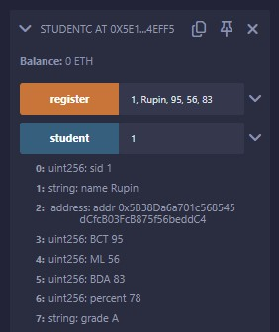

Practical 9: Write a smart contract to create a voting application.

Code:

|  |
| --- |
| //SPDX-License-Identifier: MIT  pragma solidity ^0.8.0;  contract voting { mapping(string => uint256) public c; mapping(address => bool) public voters; string[] public cn;  constructor(string[] memory candN) { cn = candN;  } function vote(string memory caNm) public { require(!voters[msg.sender], "Already Voting Done."); bool ce = false; for (uint256 i = 0; i < cn.length; i++) { if (keccak256(bytes(caNm)) == keccak256(bytes(cn[i]))) { ce = true; break;  } } require(ce, "Candidate does not exist."); c[caNm]++; voters[msg.sender] = true;  } function getVoterC(string memory canM) public view returns (uint256) { return c[canM];  } function getWinner() public view returns (string memory) { string memory winner; |
| uint256 temp = 0; for (uint256 j = 0; j < cn.length; j++) { if (getVoterC(cn[j]) > temp) { temp = getVoterC(cn[j]); winner = cn[j];  } } return winner;  } function showPercentage(string memory canM) public view returns (uint256) { uint256 total; for (uint256 i = 0; i < cn.length; i++) { total = total + getVoterC(cn[i]);  }  uint256 per = getVoterC(canM) * (100 / total); return per;  }  } |

Output:

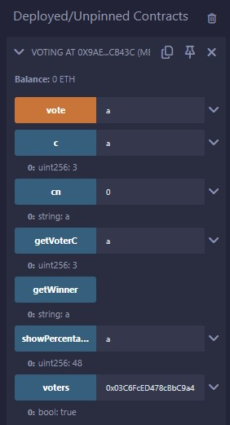

Practical 10A: Write a smart contract for Single Level Inheritance.

Code:

|  |
| --- |
| //SPDX-License-Identifier: MIT  pragma solidity ^0.8.0;  contract singer{ string n; string[2] so; function setN(string memory a, string[2] memory arr) public { n = a; so = arr;  }  } contract song is singer{ function getVal() public view returns (string memory, string[2] memory){ return (n, so);  }  } contract test{ song s = new song(); function tInherit() public returns(string memory, string[2] memory){  s.setN("Iqlipse Nova", ["Khwab", "Sajke"]); return s.getVal();  }  } |

Output:

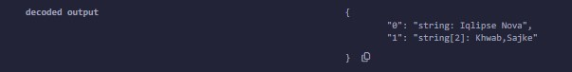

Practical 10B: Write a smart contract for Multi-Level Inheritance.

Code:

|  |
| --- |
| //SPDX-License-Identifier: MIT  pragma solidity ^0.8.0;  contract college { string internal cname; string internal pname;  function setCollege(string memory cn, string memory pn) public { cname = cn; pname = pn;  }  } contract student is college { string internal sname; uint internal rollno;  function setStudent(string memory sn, uint rn) public { sname = sn; rollno = rn;  }  } contract exam is student { uint8[5] marks;    function setMarks(uint8[5] memory m) public { marks = m;  }  function getPercentage() public view returns(uint) {    } function getDetails() public view returns(string memory, string memory, string memory, uint, uint) { uint total = 0; for(uint i = 0; i < 5; i++) { total += marks[i];  }  uint per = total/5; return (cname, pname, sname, rollno, per); |

}

}

Output:

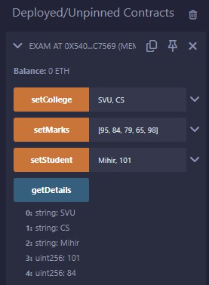

Practical 10C: Write a smart contract for Multiple Inheritance.

Code:

|  |
| --- |
| //SPDX-License-Identifier: MIT  pragma solidity ^0.8.0;  contract employee{ string n; uint mid; uint sal; function setE(string memory a, uint b, uint c) public { n = a; mid = b; sal = c;  }  } contract department{ string dep; function setD(string memory a) public { dep = a;  }  } contract salary is employee, department{ uint HRA; function calHRA() public returns(uint){ if (sal >= 15000){  HRA = 5000;  }  else if(sal >= 25000){  HRA = 10000;  } else{  HRA = 2000;  } return HRA;  }  function getVal() public view returns (string memory, uint, uint, string memory, uint){ return (n, mid, sal, dep, HRA);  }  } |

contract test{ salary s = new salary();

|  |
| --- |
| function tInherit() public returns(string memory, uint, uint, string memory, uint){  s.setE("Mihir Nagda", 101, 15000);  s.setD("CS");  s.calHRA(); return s.getVal();  }  } |

Output:

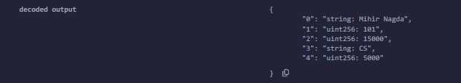

Practical 10D: Write a smart contract for Hierarchical Inheritance.

Code:

|  |
| --- |
| //SPDX-License-Identifier: MIT  pragma solidity ^0.8.0;  contract animal{ uint legs; string color; function setA(uint a, string memory b) public { legs = a; color = b;  }    } contract dog is animal{ string name; string species; function setVal(string memory a, string memory b) public { name = a; species = b;  } function getVal() public view returns (uint, string memory, string memory, string memory){ return (legs, color, name, species);  }  }  contract cat is animal{ string name; string species;  function setVal(string memory a, string memory b) public { name = a; species = b;  }  function getVal() public view returns (uint, string memory, string memory, string memory){ return (legs, color, name, species);  }  } contract test{ |

dog d = new dog(); cat c = new cat();

|  |
| --- |
| function dInherit() public returns(uint, string memory, string memory, string memory){  d.setA(4, "Brown");  d.setVal("Tom", "Labrador"); return d.getVal();  } function cInherit() public returns(uint, string memory, string memory, string memory){  c.setA(4, "White");  c.setVal("Goldie", "Indie"); return c.getVal();  }  } |

Output: cInherit:

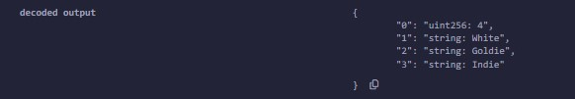

dInherit:

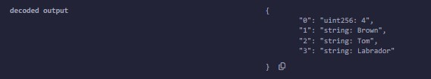

Practical 11: Creating a simple DApp for performing basic mathematical operations on two numbers.

Part 1: Setting up MetaMask and Ganache.

1. Install MetaMask Extension from [here.](https://microsoftedge.microsoft.com/addons/detail/metamask/ejbalbakoplchlghecdalmeeeajnimhm?hl=en-US)

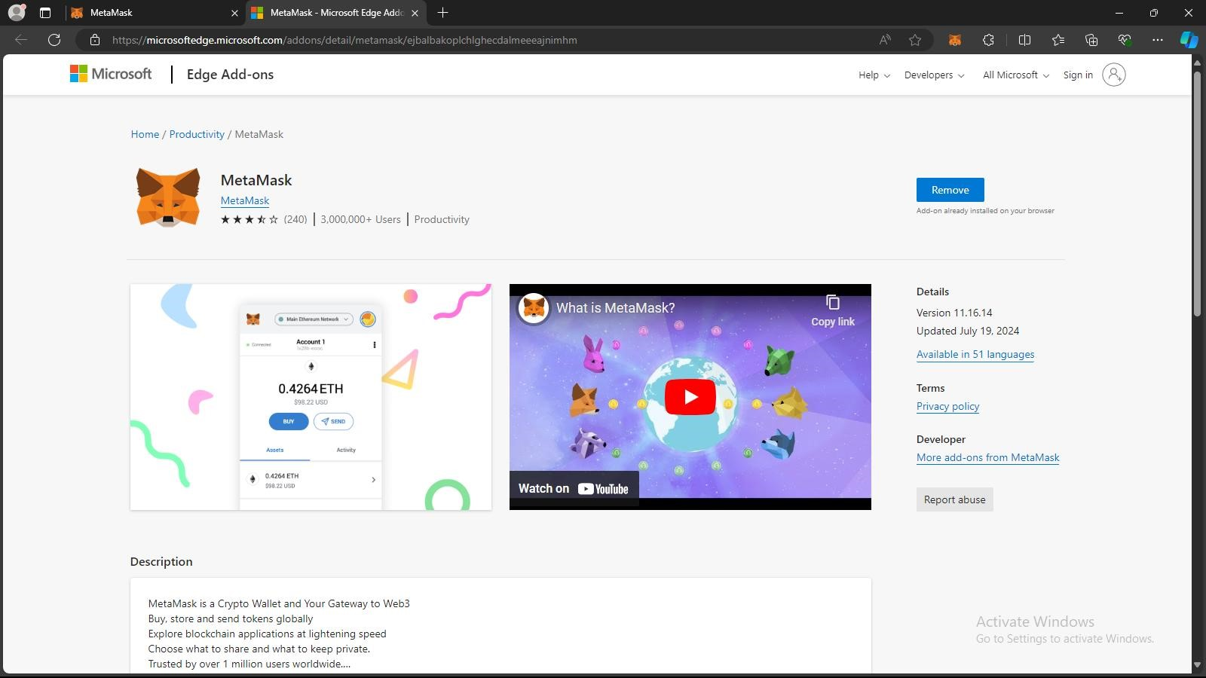

1. Install Ganache from [here.](https://archive.trufflesuite.com/ganache/)

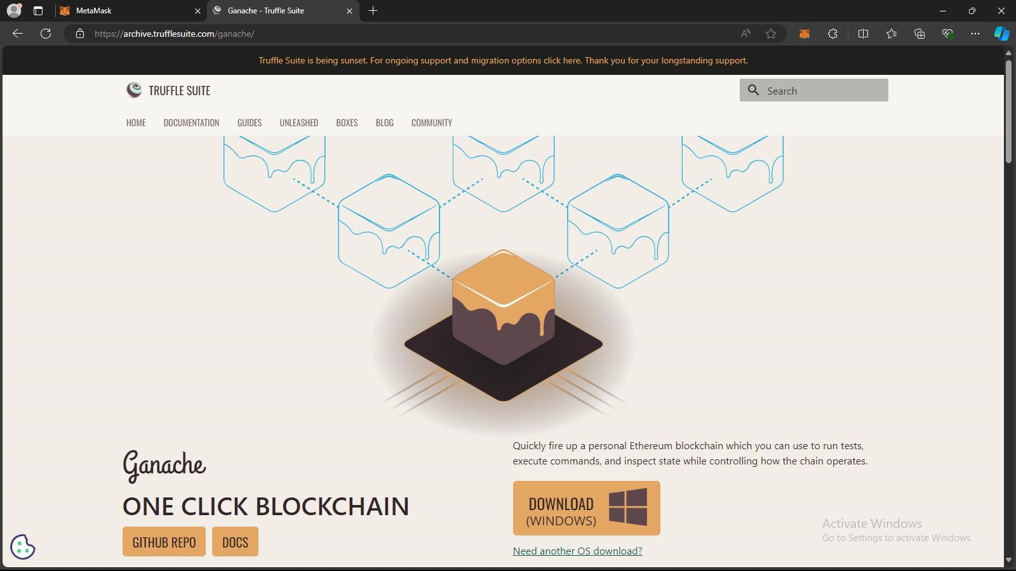

1. Create an Account on MetaMask or use an existing account.

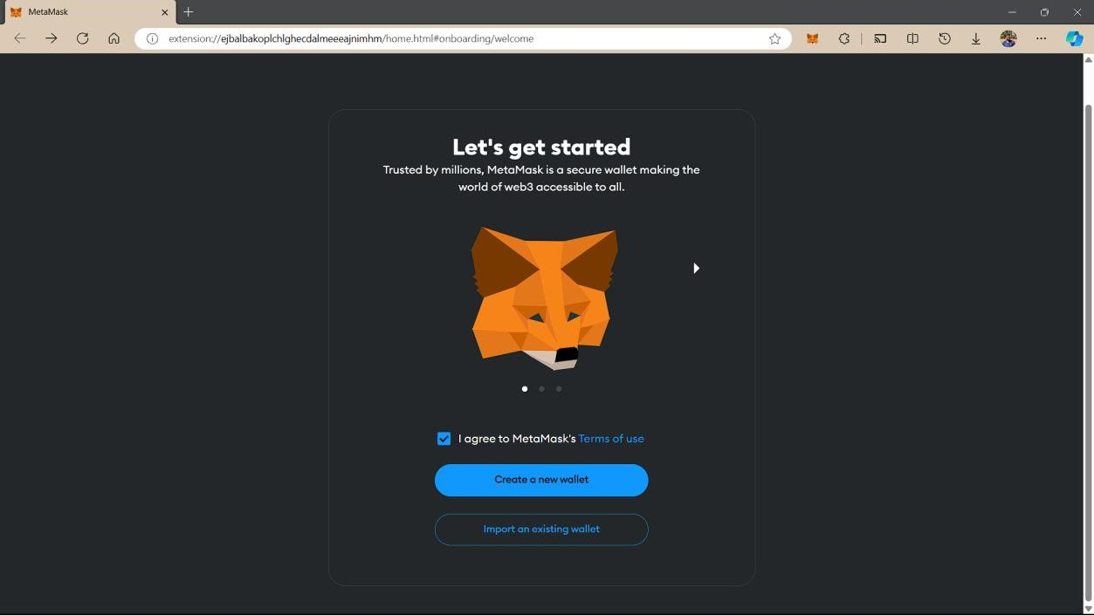

1. Start a new workspace in Ganache.

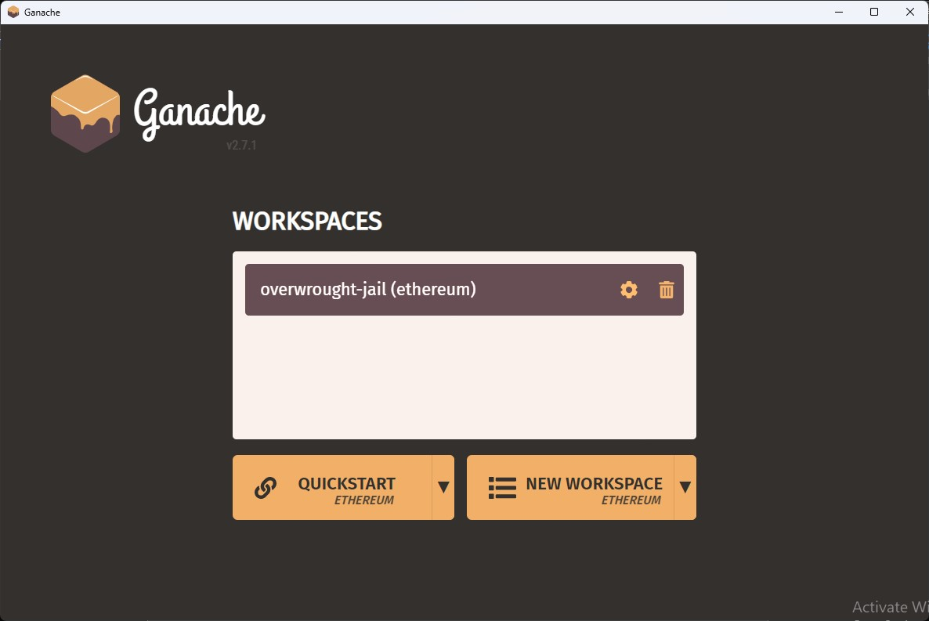

1. Go to MetaMask. Click on the Network Name → Add Network → Add Network Manually.

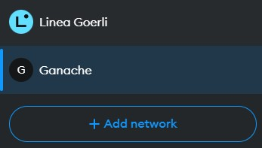

1. Give the Network a name of your choice.
2. Copy the RPC Server URL from Ganache GUI and paste it in the given box. The default Chain ID is 1337.
3. Give the currency symbol as ETH. Save the network.

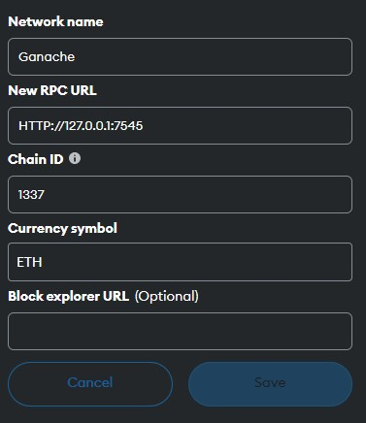

1. Go to Ganache and Click on the key symbol. Copy the private key.

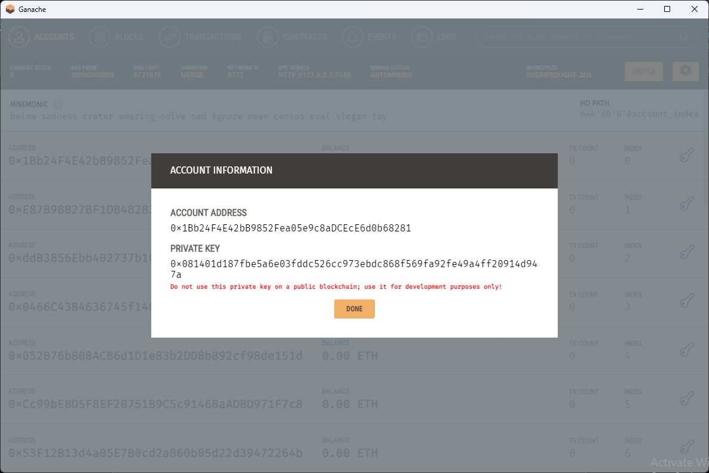

1. Go to MetaMask and click on Account Name. Select Add Account or

Hardware Wallet → Import Account and paste the private key in the given box.

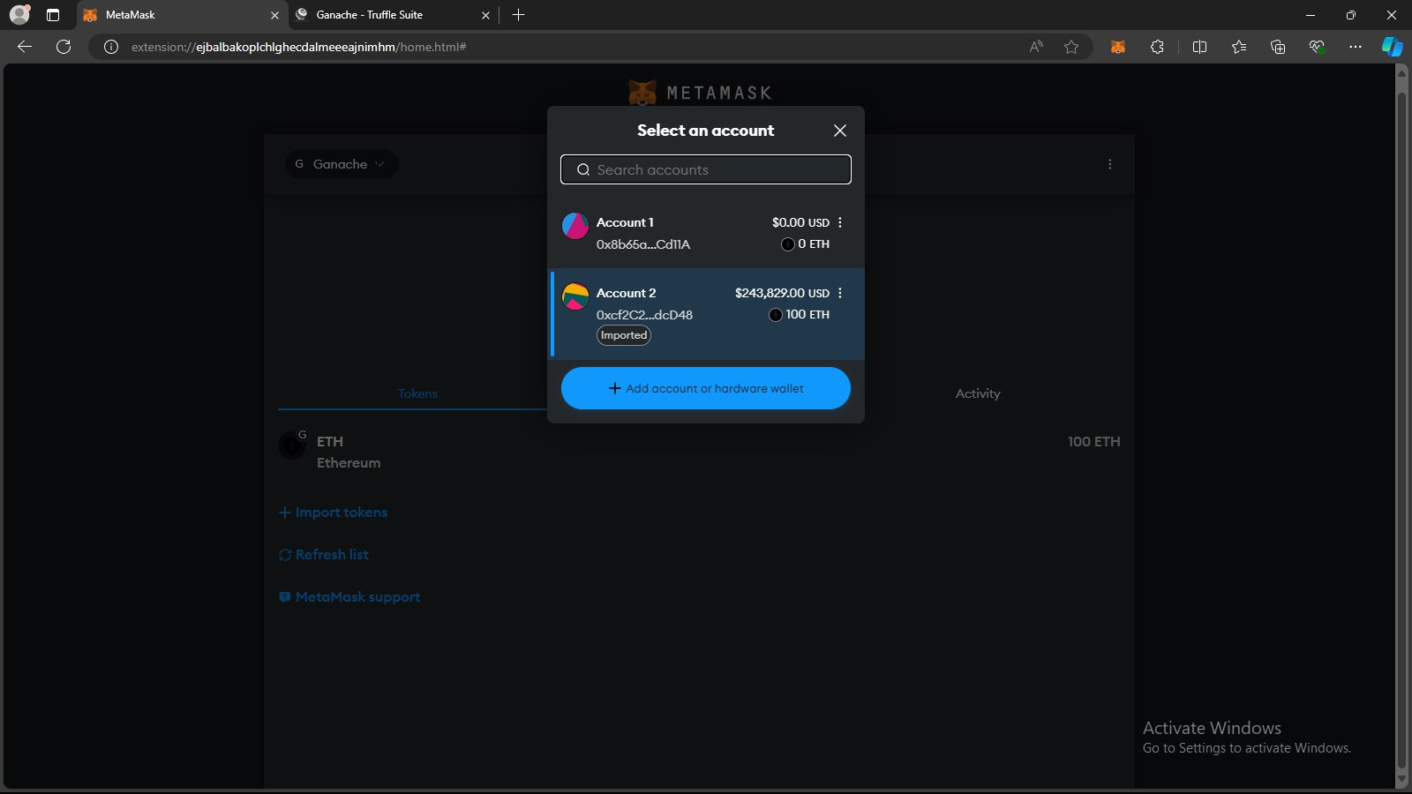

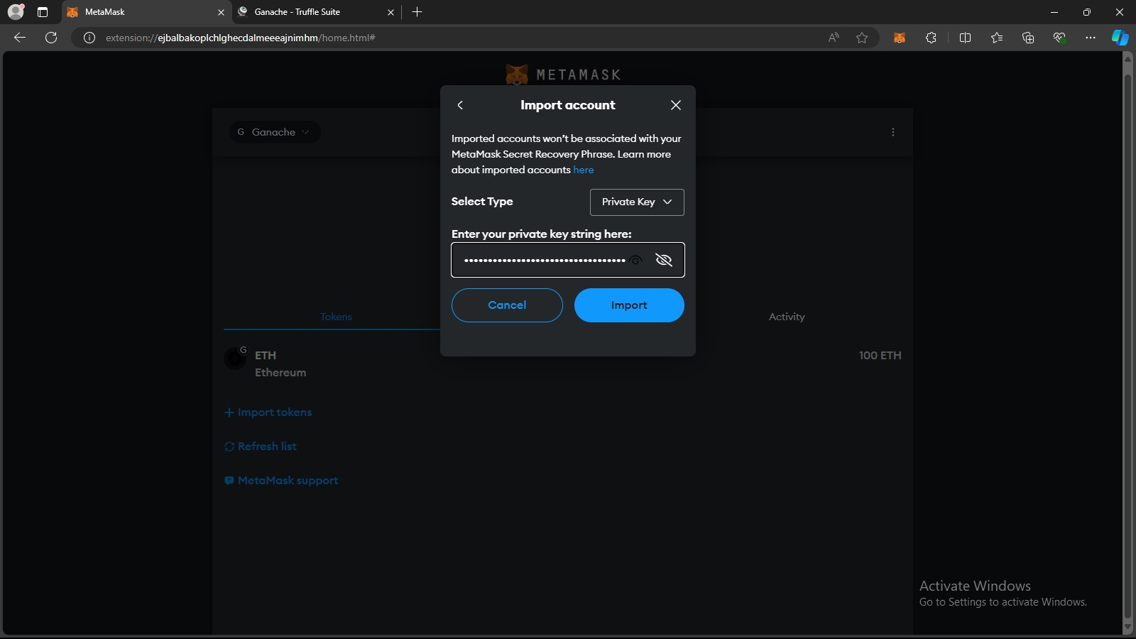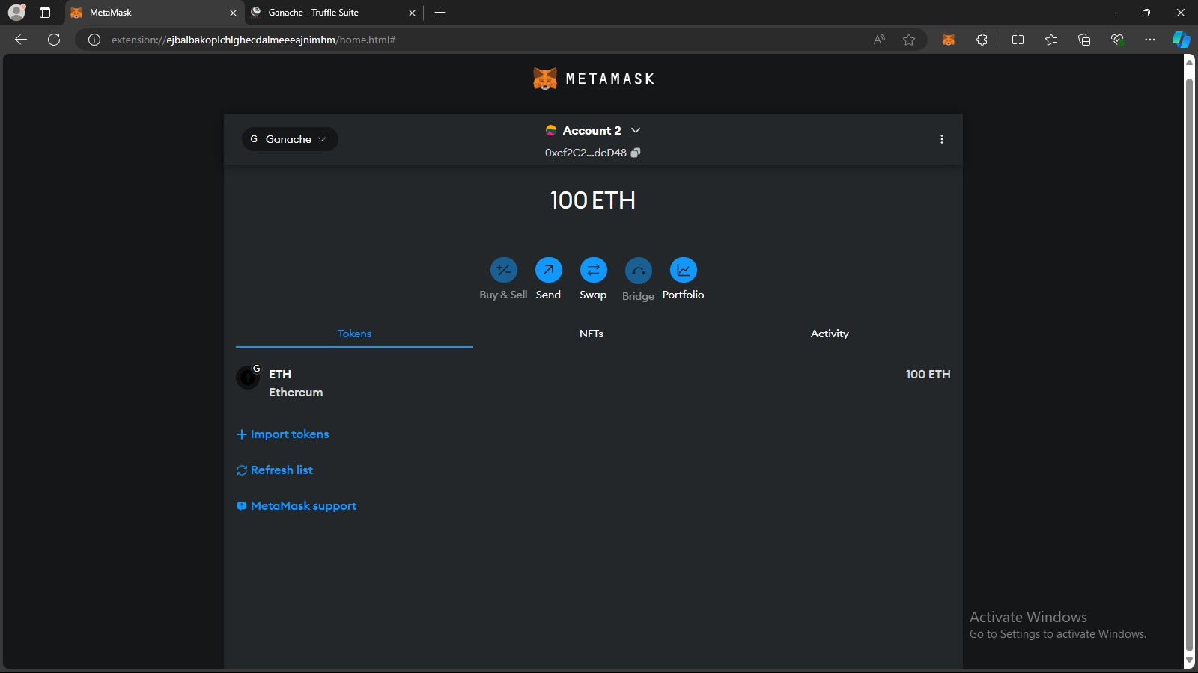

Part 2: Setting up VS Code.

Prerequisites:

1. Check if node and npm are installed with the following commands node -v & npm -v
2. Install truffle, ganache & lite-server using the following command npm install -g truffle / npm install -g ganache / npm install lite-server --dev c. Ensure Ganache is running in the background

1. Open Terminal in VS Code and initialise Truffle with the following command

truffle init

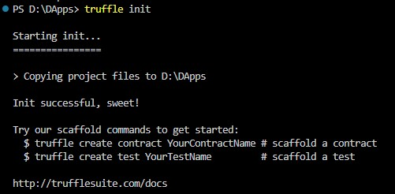

1. Create a new contract in the contracts folder. And write a smart contract for adding two number.

// SPDX-License-Identifier: MIT

pragma solidity 0.8.19;

contract Addition {

function add(uint256 a, uint256 b) public pure returns (uint256) { return a + b;

}

}

1. Create a new folder frontend and make index.html and app.js files inside.

index.html

|  |
| --- |
| <!DOCTYPE html>  <html lang="en">  <head>  <meta charset="UTF-8">  <meta name="viewport" content="width=device-width, initial-scale=1.0">  <title>DApp-1</title>  </head>  <body>  <h1>Blockchain Addition DApp</h1>  <input type="number" id="num1" placeholder="Enter first number">  <input type="number" id="num2" placeholder="Enter second number">  <button onclick="addNumber()">Add Numbers</button>  <h3>Result: <span id="result"></span></h3>  <script  src="https://cdn.jsdelivr.net/npm/web3@latest/dist/web3.min.js"></script>  <script src="app.js"></script>  </body> </html> |

app.js

|  |
| --- |
| const contractAddress = ""; // Replace with your deployed contract address const contractABI = []; // Use ABI from compiled contract  let web3; let contract;    window.addEventListener("load", async () => { if (window.ethereum) {  web3 = new Web3(window.ethereum); await window.ethereum.enable();  } else {  console.log("MetaMask not detected. Please install MetaMask."); } |
| contract = new web3.eth.Contract(contractABI, contractAddress);  });  async function addNumber() {  const num1 = document.getElementById("num1").value; const num2 = document.getElementById("num2").value; const accounts = await web3.eth.getAccounts(); console.log(num1); console.log(num2); contract.methods  .add(num1, num2)  .call({ from: accounts[0] })  .then((result) => { console.log(result);  document.getElementById("result").innerText = `${result}`;  });  } |

1. Create 1_deploy.js in the migrations folder.

|  |
| --- |
| const Addition = artifacts.require("Addition");    module.exports = async function (deployer) { await deployer.deploy(Addition);  const instance = await Addition.deployed();  console.log("Addition deployed at:", instance.address); }; |

1. Create test.js in the test folder to verify the contracts before deploying it.

const Addition = artifacts.require("Addition");

contract("Addition", () => {

it("should add two numbers correctly", async () => { const addition = await Addition.deployed(); console.log("Contract Address: ", addition.address); const result = await addition.add(5, 3); assert.equal(result.toNumber(), 8, "Addition of 5 and 3 should be 8"); }); });

1. In the source directory create a new file bs-config.json and set the base directory as frontend.

{

"server":{

"baseDir": ["./frontend"]

} }

1. Make sure about the following things
2. In the truffle-config.js uncomment your network details. And ensure the port and network_id match with the RPC Server which can be found in Ganache

GUI

1. Ensure that solidity compiler version is set to 0.8.19 in the same file.

|  |
| --- |
| module.exports = { networks: { development: { host: "127.0.0.1", port: 7545, network_id: "5777",  }  },    // Configure your compilers compilers: { solc: {  version: "0.8.19"  }  }  }; |

1. Ensure necessary dependencies are mentioned in the package.json.

{

"dependencies": {

"lite-server": "^2.6.1"

},

"scripts": {

"start": "lite-server"

} }

1. The final directory structure should look like this

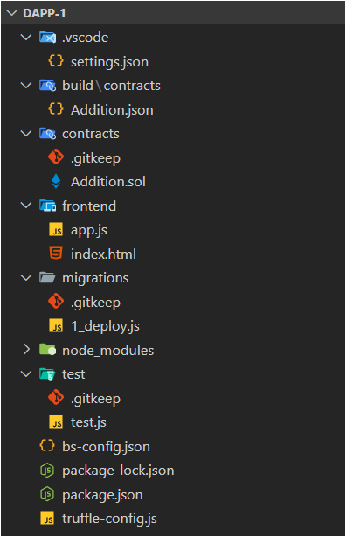

Part 3: Running the DApp.

1. In a new terminal set directory to source and run truffle compile command.

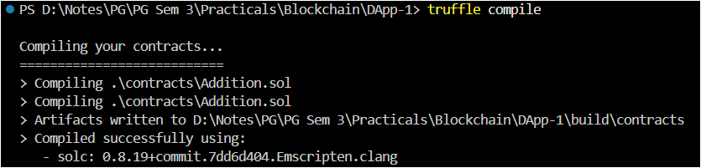

1. Go to build → contracts → Addition.json. Look for abi and Copy the complete array. Paste it in the contractABI constant inside app.js.

|  |
| --- |
| const contractABI = [{ inputs: [ {  internalType: "uint256", name: "a", type: "uint256",  }, {  internalType: "uint256", name: "b", type: "uint256",  }, ], name: "add", outputs: [ {  internalType: "uint256", name: "", type: "uint256",  }, ],  stateMutability: "pure", type: "function",  },  ]; |

1. Next run truffle migrate. Make note of the Contract Address displayed in the terminal.

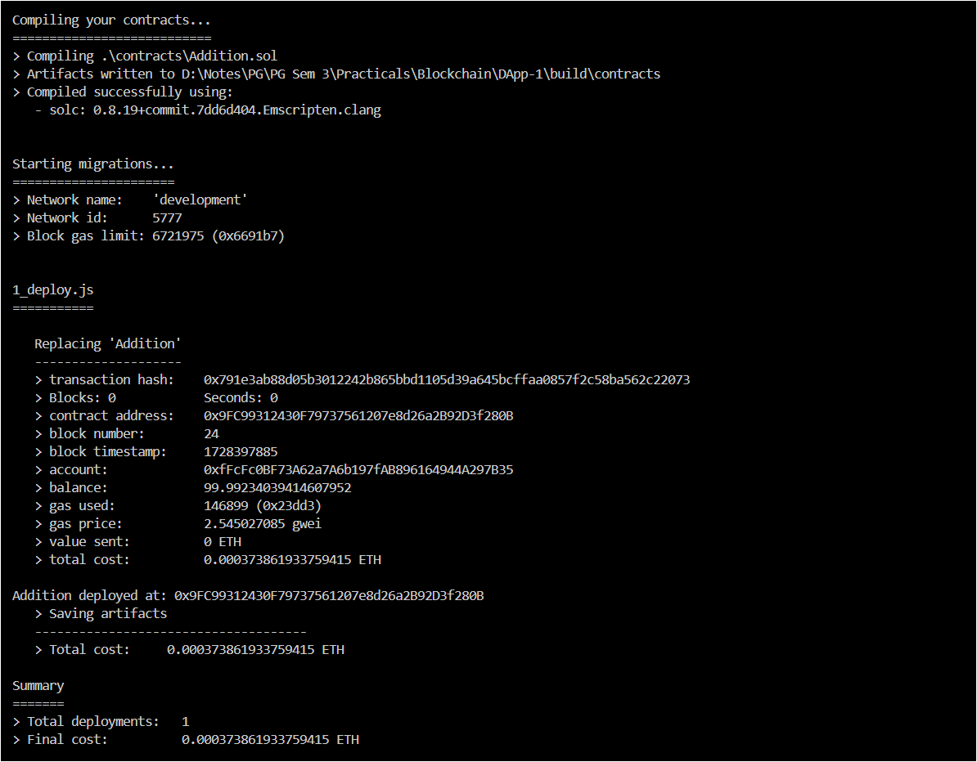

1. Copy the contract address and paste it in the contractAddress constant in the app.js file.

const contractAddress = "0xf3539bF7942055a8944EB7048A15450c05b1815A";

1. Run truffle test to ensure our contract is correct.

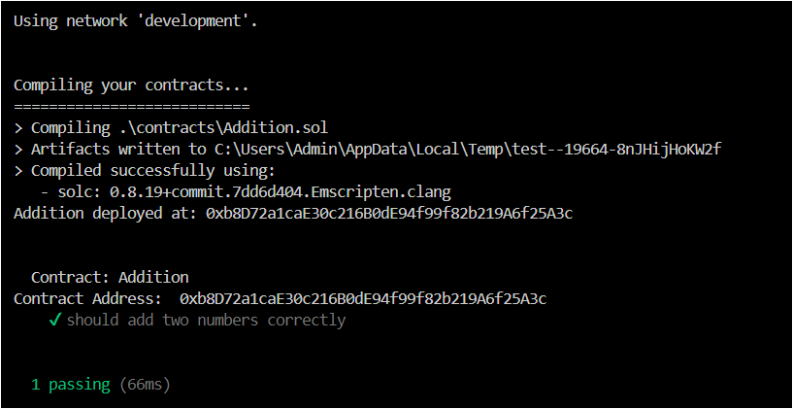

1. Run npm start if everything is correct.

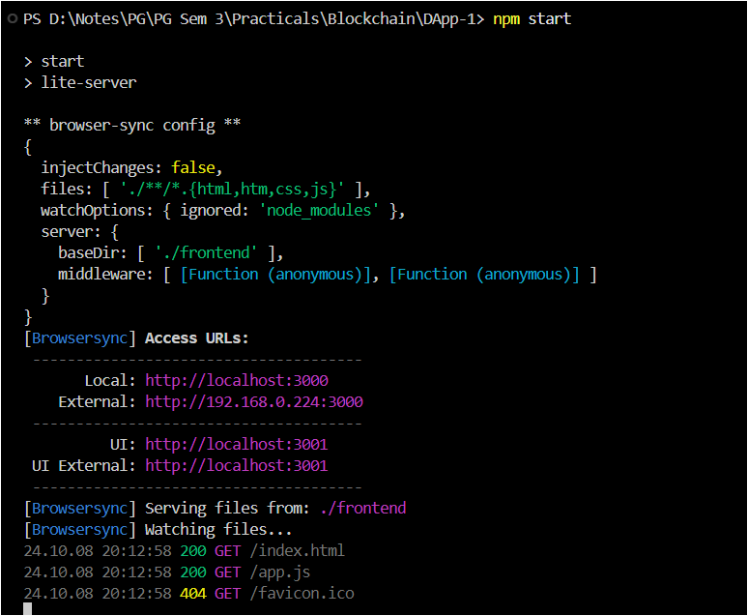

1. Sign in to MetaMask and grant the required access.

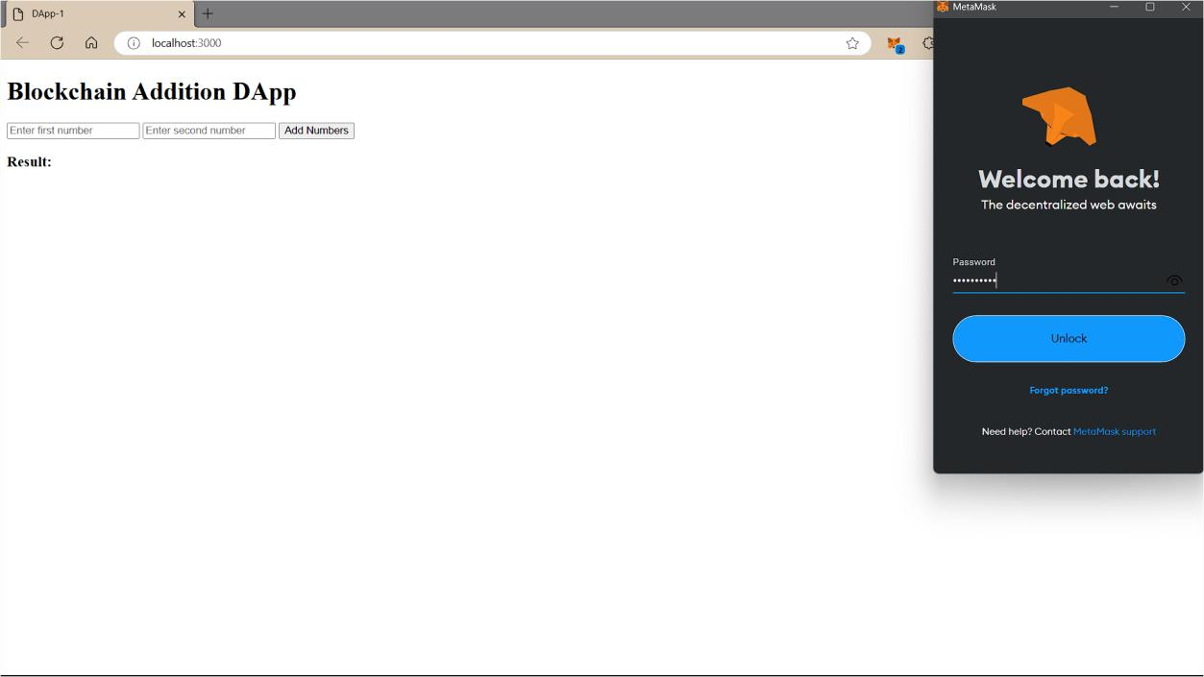

1. Give the input and click on Add Numbers. The result should be displayed.

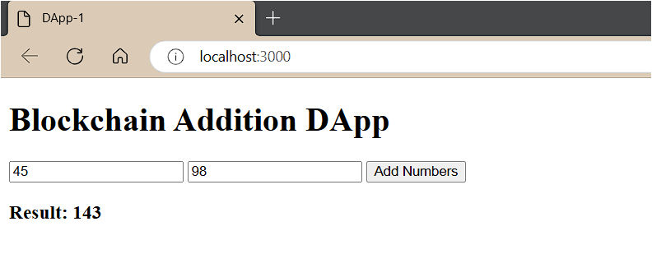

Part 4: Modify the DApp to integrate subtraction, multiplication & division operations.

1. Make changes in the smart contract (Operations.sol → I have renamed the

file)

|  |
| --- |
| // SPDX-License-Identifier: MIT    pragma solidity 0.8.19;    contract Operations {  function add(uint256 a, uint256 b) public pure returns (uint256) { return a + b;  }  function sub(uint256 a, uint256 b) public pure returns (uint256) { return a - b;  }  function mul(uint256 a, uint256 b) public pure returns (uint256) { return a * b;  }  function div(uint256 a, uint256 b) public pure returns (uint256) { return a / b;  }  } |

1. Modify index.html to accommodate other buttons and onClick functions.

<!DOCTYPE html>

<html lang="en">

<head>

<meta charset="UTF-8" />

<meta name="viewport" content="width=device-width, initial-scale=1.0" />

<title>DApp-1</title>

</head>

<body>

<h1>Blockchain Addition DApp</h1>

|  |
| --- |
| Number 1:  <input type="number" id="num1" placeholder="Enter first number" />  <br /><br /> Number 2:  <input type="number" id="num2" placeholder="Enter second number" /> <br />  <h2>Choose Operation:</h2>  <button onclick="addNumber()">Add</button> <button onclick="subNumber()">Sub</button> <button onclick="mulNumber()">Mul</button> <button onclick="divNumber()">Div</button>  <h2>Result:</h2>  <h3>Addition: <span id="resultA"></span></h3>  <h3>Subtraction: <span id="resultS"></span></h3>  <h3>Multiplication: <span id="resultM"></span></h3>  <h3>Division: <span id="resultD"></span></h3>  <script  src="https://cdn.jsdelivr.net/npm/web3@latest/dist/web3.min.js"></script>  <script src="app.js"></script>  </body>  </html> |

1. Similarly modify app.js.

|  |
| --- |
| const contractAddress = ""; // Replace with your deployed contract address const contractABI = []; // Use ABI from compiled contract  let web3; let contract;    window.addEventListener("load", async () => { if (window.ethereum) {  web3 = new Web3(window.ethereum); await window.ethereum.enable();  } else {  console.log("MetaMask not detected. Please install MetaMask."); } |

|  |
| --- |
| contract = new web3.eth.Contract(contractABI, contractAddress);  });  async function addNumber() {  const num1 = document.getElementById("num1").value; const num2 = document.getElementById("num2").value; const accounts = await web3.eth.getAccounts(); console.log(num1); console.log(num2); contract.methods  .add(num1, num2)  .call({ from: accounts[0] })  .then((result) => { console.log(result);  document.getElementById("resultA").innerText = `${result}`;  });  }  async function subNumber() {  const num1 = document.getElementById("num1").value; const num2 = document.getElementById("num2").value; const accounts = await web3.eth.getAccounts(); console.log(num1); console.log(num2); contract.methods  .sub(num1, num2)  .call({ from: accounts[0] })  .then((result) => { console.log(result);  document.getElementById("resultS").innerText = `${result}`;  });  }  async function mulNumber() {  const num1 = document.getElementById("num1").value; const num2 = document.getElementById("num2").value; const accounts = await web3.eth.getAccounts(); console.log(num1); |
| console.log(num2); contract.methods  .mul(num1, num2)  .call({ from: accounts[0] })  .then((result) => { console.log(result);  document.getElementById("resultM").innerText = `${result}`;  });  }  async function divNumber() {  const num1 = document.getElementById("num1").value; const num2 = document.getElementById("num2").value; const accounts = await web3.eth.getAccounts(); console.log(num1); console.log(num2); contract.methods  .div(num1, num2)  .call({ from: accounts[0] })  .then((result) => { console.log(result);  document.getElementById("resultD").innerText = `${result}`;  });  } |

1. Modify 1_deploy.js (If you haven’t renamed leave it as is)

|  |
| --- |
| const Operations = artifacts.require("Operations");    module.exports = async function (deployer) { await deployer.deploy(Operations);  const instance = await Operations.deployed();  console.log("Operations deployed at:", instance.address); }; |

1. Update test.js to include different test cases.

|  |
| --- |
| const Operations = artifacts.require("Operations");    contract("Operations", () => { let operationsInstance;    before(async () => {  operationsInstance = await Operations.deployed(); });  it("should add two numbers correctly", async () => {  console.log("Contract Address: ", operationsInstance.address); const resultA = await operationsInstance.add(5, 2);  assert.equal(resultA.toNumber(), 7, "Addition of 5 and 2 should be 7"); });  it("should subtract two numbers correctly", async () => { console.log("Contract Address: ", operationsInstance.address); const resultS = await operationsInstance.sub(5, 2);  assert.equal(resultS.toNumber(), 3, "Subtraction of 5 and 2 should be 3"); });  it("should multiply two numbers correctly", async () => { console.log("Contract Address: ", operationsInstance.address); const resultM = await operationsInstance.mul(5, 2);  assert.equal(resultM.toNumber(), 10, "Multiplication of 5 and 2 should be  10");  });  it("should divide two numbers correctly", async () => {  console.log("Contract Address: ", operationsInstance.address); const resultD = await operationsInstance.div(5, 5);  assert.equal(resultD.toNumber(), 1, "Division of 5 and 5 should be 1"); });  }); |

1. Run the DApp following the same steps in Part 3.

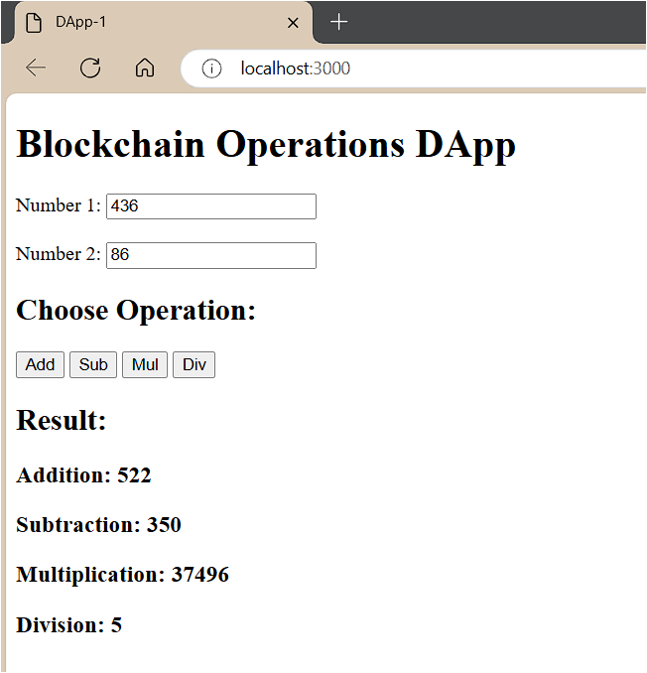

Practical 12A: Create a DApp to calculate factorial of a number.

1. In a new terminal run truffle init
2. Create a new contract to calculate Factorial.

|  |
| --- |
| // SPDX-License-Identifier: MIT    pragma solidity 0.8.19;    contract factorial {  function fact(uint n) public pure returns (uint) { if (n == 0) { return 1; } else {  uint result = 1;  for (uint i = 1; i <= n; i++) { result *= i;  }  return result;  }  }  } |

2. Make a new folder frontend and create two files, index.html & app.js.

index.html

<!DOCTYPE html>

<html lang="en">

<head>

<meta charset="UTF-8" />

<meta name="viewport" content="width=device-width, initial-scale=1.0" />

<title>DApp-2</title>

</head>

<body>

<h1>Blockchain Factorial DApp</h1> Number:

<input type="number" id="num" placeholder="Enter Number" />

<br /><br />

<h2>Calculate Factorial:</h2>

<button onclick="facto()">Calculate</button>

<h2>Result: <span id="result"></span></h2>

<script

src="https://cdn.jsdelivr.net/npm/web3@latest/dist/web3.min.js"></script>

<script src="app.js"></script>

</body> </html>

app.js (get contractABI & contractAddress after compilation and migration respectively)

|  |
| --- |
| const contractAddress = ""; // Replace with your deployed contract address const contractABI = []; // Use ABI from compiled contract  let web3; let contract;    window.addEventListener("load", async () => { if (window.ethereum) {  web3 = new Web3(window.ethereum); await window.ethereum.enable();  } else {  console.log("MetaMask not detected. Please install MetaMask."); }  contract = new web3.eth.Contract(contractABI, contractAddress);  });  async function facto() {  const num = document.getElementById("num").value; const accounts = await web3.eth.getAccounts(); console.log(num); contract.methods |
| .fact(num)  .call({ from: accounts[0] })  .then((result) => { console.log(result);  document.getElementById("result").innerText = `${result}`;  });  } |

1. Create 1_deploy.js in migrations folder.

|  |
| --- |
| const factorial = artifacts.require("factorial");    module.exports = async function (deployer) { await deployer.deploy(factorial);  const instance = await factorial.deployed();  console.log("Operations deployed at:", instance.address); }; |

1. Run the DApp by npm start. Connect wallet and test.

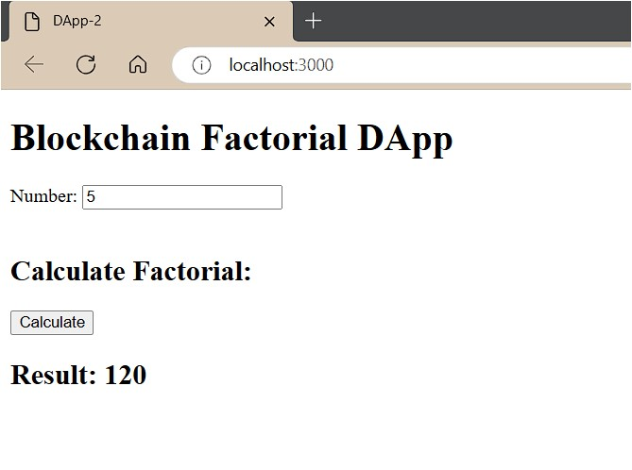

Practical 12B: Create a DApp to implement transactions between two accounts.

1. index.html

<!DOCTYPE html>

<html lang="en">

<head>

<meta charset="UTF-8" />

<meta name="viewport" content="width=device-width, initial-scale=1.0" />

<title>DApp-3</title>

</head>

<body>

<h1>Blockchain Transactions DApp</h1>

<h2>Send Ether:</h2>

<input type="text" id="toAddr" placeholder="To Address" />

<input type="number" id="amount" placeholder="Amount" />

<button onclick="send()">Send</button>

<h2>Check Balance:</h2>

<button onclick="checkBalance()">Check Balance</button>

<p>Your Balance is: <span id="bal"></span></p>

<script

src="https://cdn.jsdelivr.net/npm/web3@latest/dist/web3.min.js"></script>

<script src="app.js"></script>

</body> </html>

1. app.js

|  |
| --- |
| const contractAddress = ""; // Replace with your deployed contract address const contractABI = []; // Use ABI from compiled contract  let web3; let contract;    window.addEventListener("load", async () => { if (window.ethereum) {  web3 = new Web3(window.ethereum); |

|  |
| --- |
| await window.ethereum.enable();  } else {  console.log("MetaMask not detected. Please install MetaMask.");  }  contract = new web3.eth.Contract(contractABI, contractAddress);  });  async function send() {  const accounts = await web3.eth.getAccounts();  const amount = web3.utils.toWei(document.getElementById('amount').value, 'ether'); const toAddress = document.getElementById('toAddr').value; const sender = accounts[0];    console.log("Sender: ", accounts[0]); console.log("Receiver: ", toAddress); console.log("Amount: ", amount);    if (amount <= 0) {  alert("Amount must be greater than 0"); return;  }  else if (toAddress == "") {  alert("Please enter receiver address"); return;  } else {  contract.methods.transfers(toAddress).send({ from: sender, value: amount  }).on('transactionHash', (hash) => { console.log('Transaction Hash:', hash);  }).on('receipt', (receipt) => {  console.log('Transaction Receipt:', receipt);  }).on('error', (error) => { |
| console.error('Error:', error);  });  }  };  async function checkBalance() {  const accounts = await web3.eth.getAccounts(); const balance = await web3.eth.getBalance(accounts[0]); const balanceInEther = web3.utils.fromWei(balance, 'ether'); document.getElementById("bal").innerText = `${balanceInEther}`; } |

1. transactions.sol

|  |
| --- |
| // SPDX-License-Identifier: MIT pragma solidity 0.8.19;    contract transactions {  event Transfer(address indexed from, address indexed to, uint256 value);    function transfers(address payable _to) public payable { require(msg.value > 0, "Send some ether");  _to.transfer(msg.value);  emit Transfer(msg.sender, _to, msg.value);  }  receive() external payable {  emit Transfer(msg.sender, address(this), msg.value);  }  } |

1. 1_deploy.js

const transaction = artifacts.require("transactions");

module.exports = async function (deployer) {

await deployer.deploy(transaction); const instance = await transaction.deployed(); console.log("Contract deployed at:", instance.address);

};

1. bs-config.json

{

"server":{

"baseDir": ["./frontend"]

} }

1. Output:

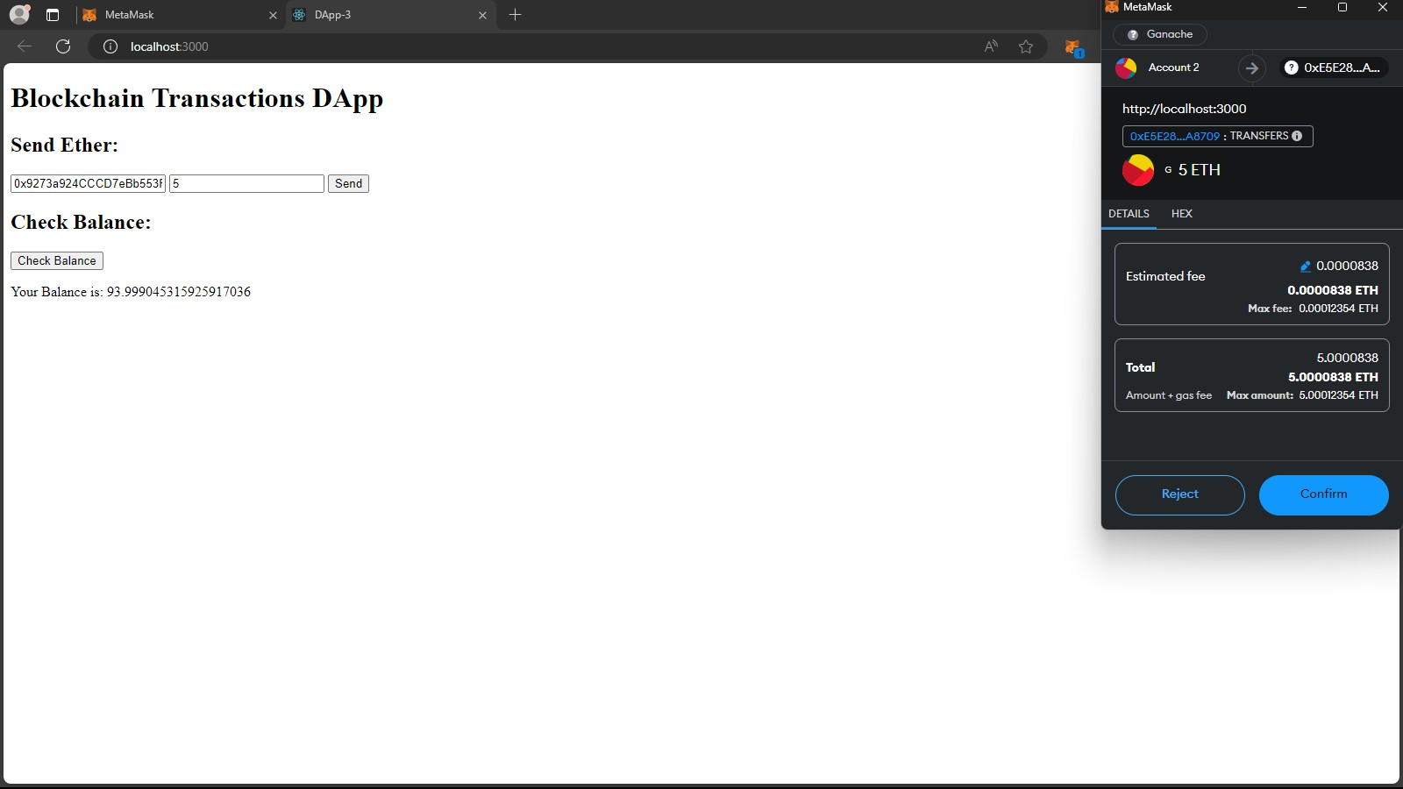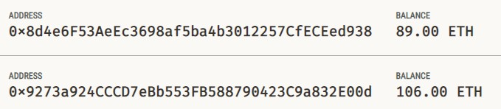

Practical 12C: Create a DApp to implement elections.

1. index.html

|  |
| --- |
| <!DOCTYPE html>  <html lang="en">    <head>  <meta charset="UTF-8">  <meta name="viewport" content="width=device-width, initial-scale=1.0">  <title>DApp-4</title>  </head>    <body>  <h1>Blockchain Voting DApp</h1>  <h2>Select Candidate to Vote</h2>  <button onclick="vote('Can1')">Candidate 1</button> <button onclick="vote('Can2')">Candidate 2</button> <button onclick="vote('Can3')">Candidate 3</button>  <br><br>  <h2>Check Results:</h2>  <button onclick="checkResult()">Check Result</button>  <p>The Winner Is: <span id="result"></span></p>    <script src="https://cdn.jsdelivr.net/npm/web3@latest/dist/web3.min.js"></script>  <script src="app.js"></script>  </body>    </html> |

1. app.js

|  |
| --- |
| const contractAddress = ""; // Replace with your deployed contract address const contractABI = []; // Use ABI from compiled contract  let web3; let contract; |
| window.addEventListener("load", async () => { if (window.ethereum) {  web3 = new Web3(window.ethereum); await window.ethereum.enable();  } else {  console.log("MetaMask not detected. Please install MetaMask."); }  contract = new web3.eth.Contract(contractABI, contractAddress);  });  async function vote(can) { var canM = can;  const accounts = await web3.eth.getAccounts(); const voter = accounts[0];    contract.methods.vote(canM).send({ from: voter  })  };  async function checkResult() {  const accounts = await web3.eth.getAccounts();    contract.methods.getWinner()  .call({ from: accounts[0] })  .then((winner) => {  document.getElementById("result").innerText = `${winner}`;  });  } |

1. voting.sol

|  |
| --- |
| // SPDX-License-Identifier: MIT pragma solidity 0.8.19;    contract voting {  mapping(string => uint256) public c; mapping(address => bool) public voters; string[] public cn;    constructor() {  cn = ["Can1", "Can2", "Can3"];  }  function vote(string memory caNm) public {  require(!voters[msg.sender], "Already Voting Done."); bool ce = false;  for (uint256 i = 0; i < cn.length; i++) {  if (keccak256(bytes(caNm)) == keccak256(bytes(cn[i]))) { ce = true; break;  } }  require(ce, "Candidate does not exist."); c[caNm]++;  voters[msg.sender] = true;  }  function getVoterC(string memory canM) public view returns (uint256) { return c[canM];  }  function getWinner() public view returns (string memory) { string memory winner;    uint256 temp = 0; |
| for (uint256 j = 0; j < cn.length; j++) { if (getVoterC(cn[j]) > temp) { temp = getVoterC(cn[j]); winner = cn[j];  } }  return winner;  }  function showPercentage(string memory canM) public view returns (uint256) { uint256 total;  for (uint256 i = 0; i < cn.length; i++) { total = total + getVoterC(cn[i]);  }    uint256 per = getVoterC(canM) * (100 / total); return per;  }  } |

1. 1_deploy.js

|  |
| --- |
| const vote = artifacts.require("voting");    module.exports = async function (deployer) { await deployer.deploy(vote);  const instance = await vote.deployed();  console.log("Contract deployed at:", instance.address); }; |

1. Output:

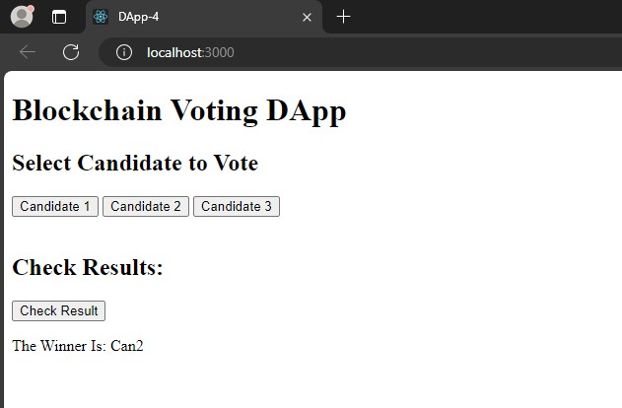

Practical 13: Storing and Retrieving files using IPFS.

Step 1: Download and Install IPFS Desktop from [here.](https://github.com/ipfs/ipfs-desktop/releases/tag/v0.38.0)

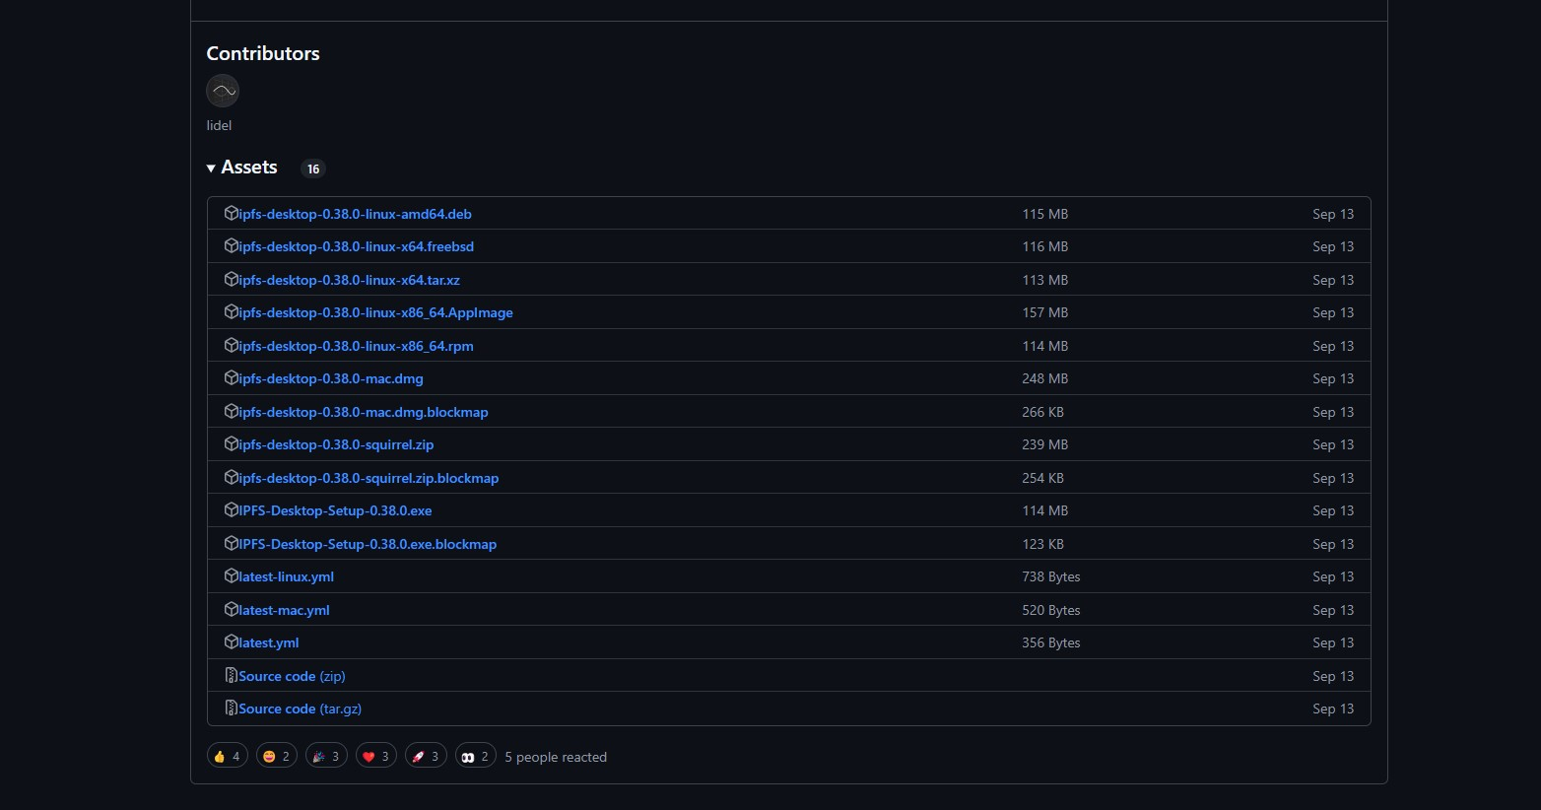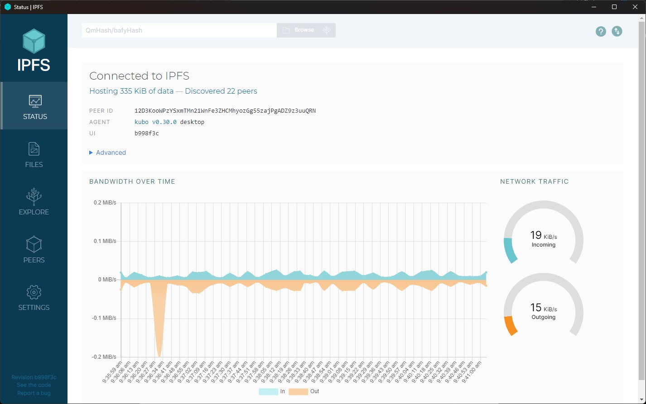

Step 2: Click on files and import a sample file.

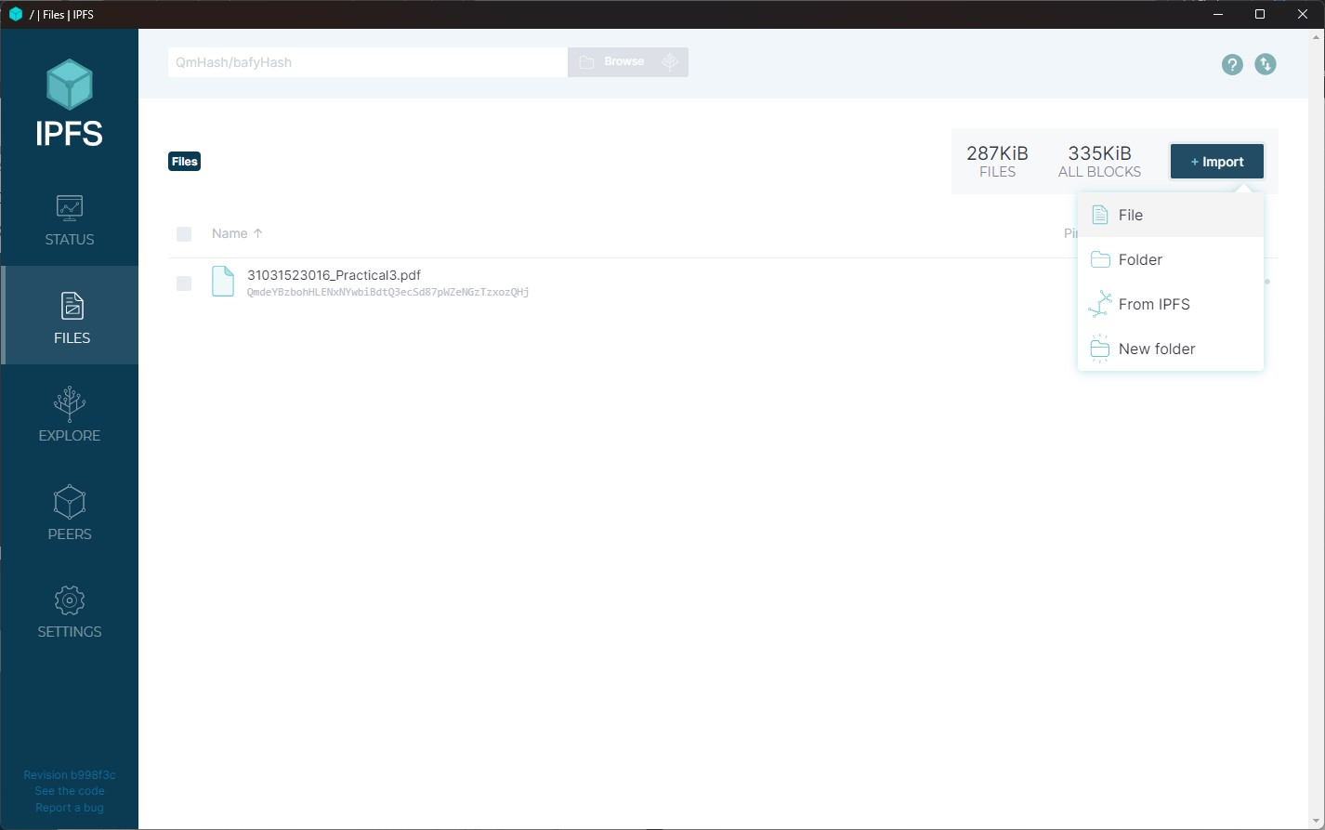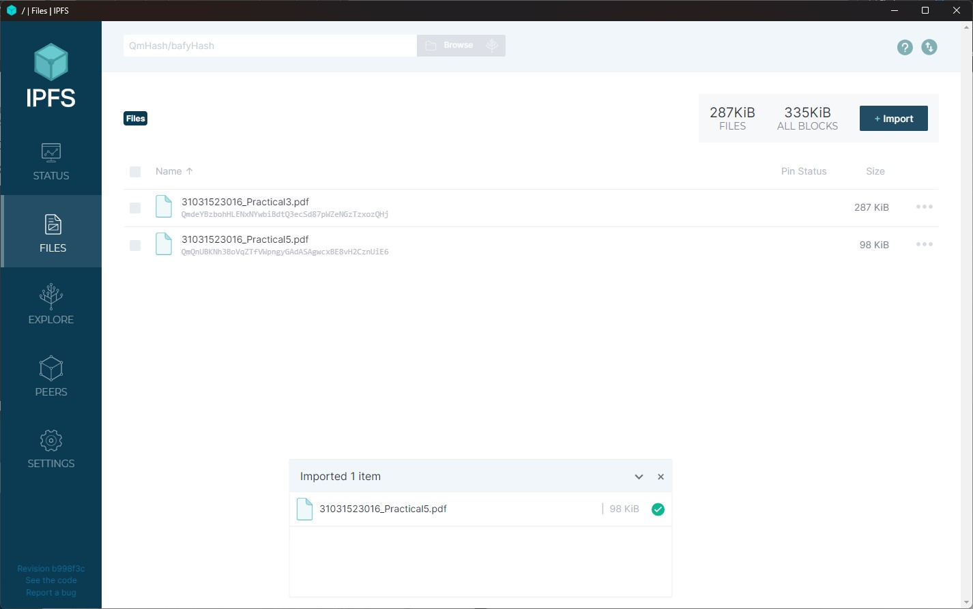

Step 3: Click on 3 dots and copy CID

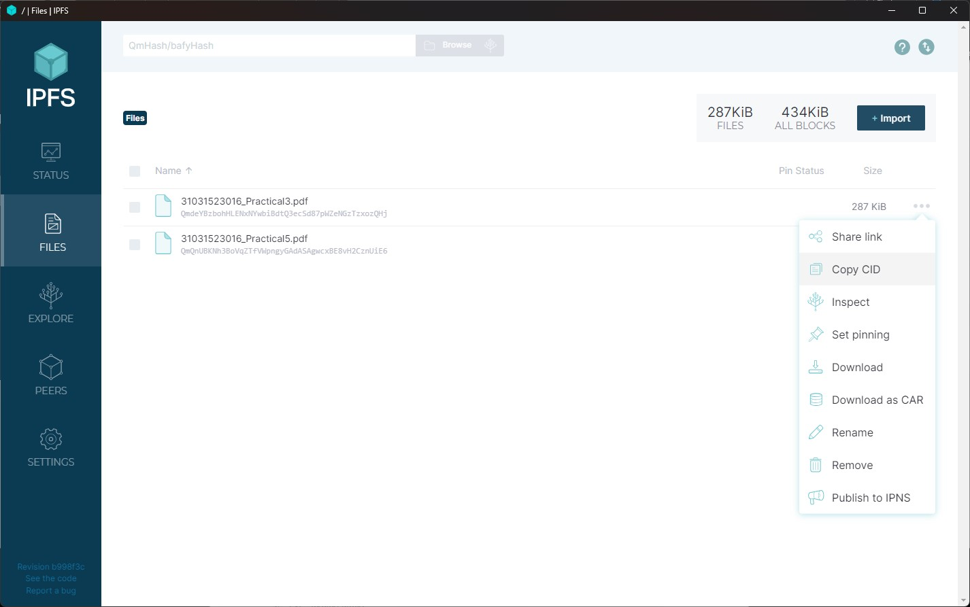

Step 4: Share the CID to someone else to open the shared file.

Step 5: Click on import → Import from IPFS

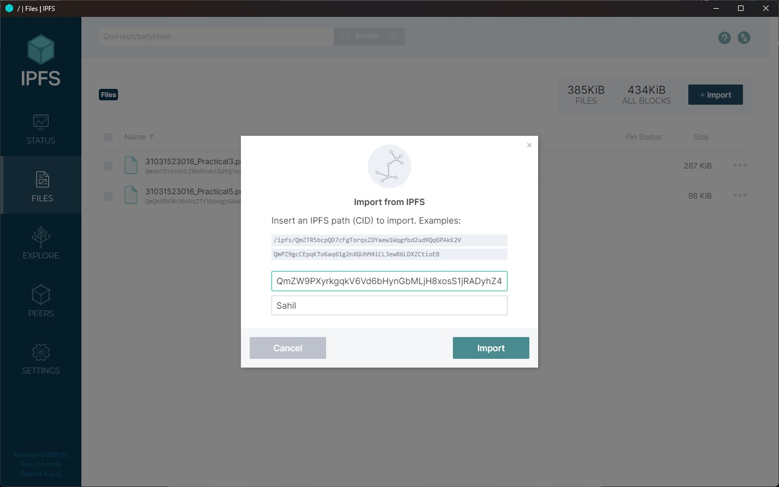

Step 6: The imported file will be visible.

